

Fundamentals of the Security in Communications

Anthony Orozco (ID: RIE0058)

# Present and Future of the Quantum Cryptography

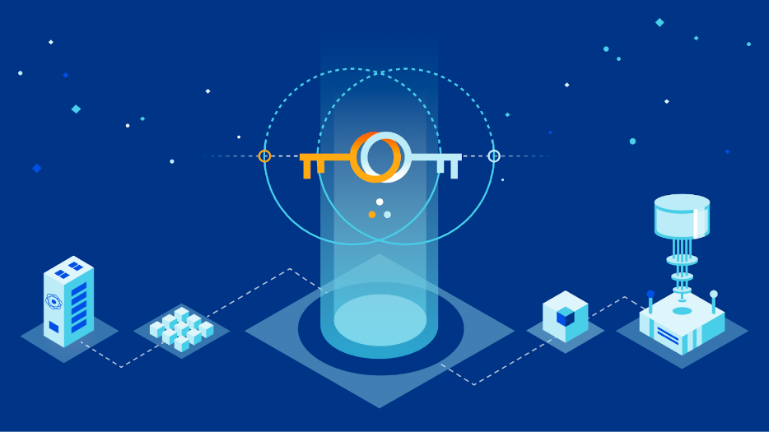

***Index***

***Quantum Cryptography 3***

***The current state of the art of quantum cryptography 5***

***Present 6***

***Examples - Present 7***

***Future 8***

***Examples – Future 9***

***Principles of function 10***

***Types of implementation and deployment 11***

***Some know real attacks in real life 13***

***Own opinion and possible own contribution 14***

***on Present and Future of the Quantum Cryptography***

***Conclusion 15***

***References 16***

# 

# *Quantum Cryptography*

Quantum Cryptography is a revolutionary technology that uses the principles of quantum mechanics to create unbreakable cryptographic protocols. It is based on the concept that information can be transmitted using photons, which are particles of light. Unlike classical cryptography, which relies on mathematical algorithms to encrypt data, quantum cryptography uses the laws of physics to ensure the security of the transmission.

One of the key methods used in quantum cryptography is the distribution of quantum keys. This involves transmitting a series of photons between two parties, with each photon representing a bit of information. By measuring the properties of the photons, the two parties can agree on a shared secret key that can be used for secure communication. Any attempt to intercept or measure the photons will cause them to be disturbed, making it impossible for an eavesdropper to obtain the key.

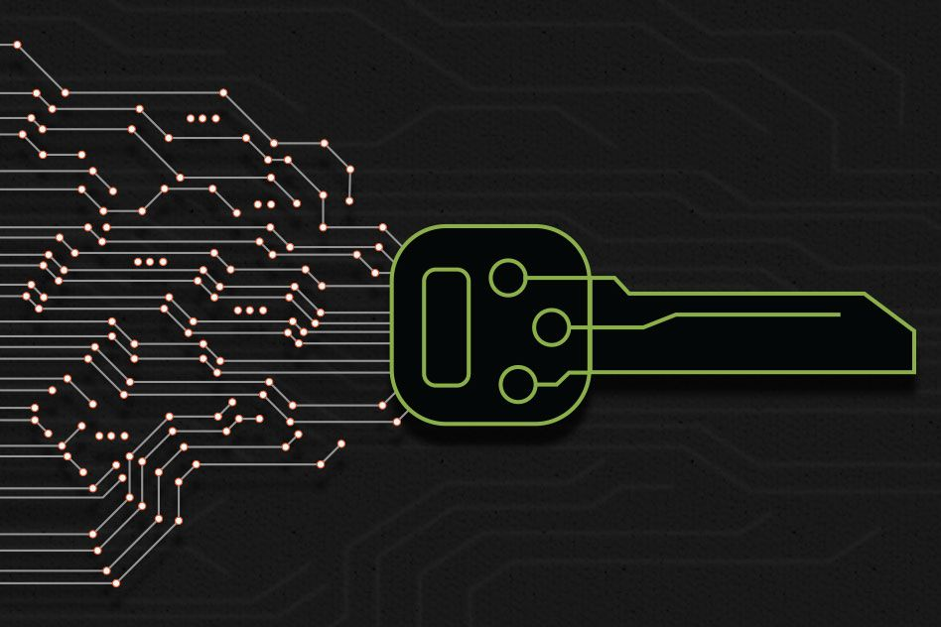

Another important protocol used in quantum cryptography is the BB84 protocol, which was developed by Charles Bennett and Gilles Brassard in 1984. This protocol uses two sets of bases, one for transmitting and one for measuring the photons, to encode the information. The sender randomly selects one of the two bases for each photon, while the receiver also randomly selects a base for each photon. By comparing the bases used, the two parties can determine whether the transmission was intercepted and take appropriate action.

In addition to these methods and protocols, there are several other emerging technologies in quantum cryptography that are likely to play a major role in its future.

Quantum key distribution networks:

These are networks that use quantum key distribution to provide secure communication between multiple parties.

Quantum random number generators:

These are devices that use the randomness of quantum mechanics to generate truly random numbers, which are essential for many cryptographic protocols.

Quantum-resistant cryptography:

This is a field of research that aims to develop cryptographic algorithms that can withstand attacks by quantum computers, which have the potential to break many of the currently used algorithms.

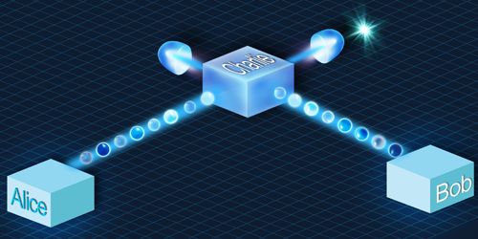

*The current state of the art of quantum cryptography*

Until September 2021, Quantum cryptography has been an area of active research and development. Quantum cryptography aims to provide secure communication channels using the principles of quantum mechanics. It utilizes the fundamental properties of quantum mechanics, such as the uncertainty principle and the no-cloning theorem, to achieve secure key distribution and secure communication.

The most well-known and widely implemented protocol in quantum cryptography is called quantum key distribution (QKD). QKD enables two parties, traditionally referred to as Alice and Bob, to establish a secure cryptographic key over an insecure channel. The security of QKD relies on the laws of quantum physics, making it resistant to eavesdropping attempts.

QKD has seen significant advancements in recent years. Some notable developments include:

Long-distance QKD:

Researchers have made progress in extending the maximum distance over which secure key distribution can be achieved. Techniques such as quantum repeaters and quantum memories have been explored to address the challenge of signal degradation over long distances.

Practical implementations:

Efforts have been made to develop more practical and efficient QKD systems. This includes the miniaturization of QKD devices, integration with existing telecommunication infrastructures, and the use of fiber-optic cables for transmission.

Device-independent QKD:

Device-independent QKD aims to eliminate vulnerabilities associated with imperfect or compromised devices. It ensures security even if the devices used in the protocol are not trusted. Several device-independent QKD protocols have been proposed and experimentally demonstrated.

Quantum network development:

The focus has shifted toward the development of quantum networks that can connect multiple users. These networks can facilitate secure communication among various parties and enable more advanced quantum cryptographic protocols.

### *Present*

Quantum cryptography has emerged as a cutting-edge technology that offers unparalleled levels of security in the field of communication. The technology is based on the principles of quantum mechanics and uses the properties of quantum particles, such as photons, to create encryption keys that are completely unbreakable. Today, quantum cryptography is being used by governments, financial institutions, and other organizations around the world to safeguard their most sensitive information from cyberattacks.

With the increasing number of cyber threats, the demand for more secure communication methods is on the rise. Quantum cryptography has already proven to be a viable solution, providing an unbreakable code that is nearly impossible to hack. As research continues, we can expect to see more advanced quantum cryptography solutions, which could further strengthen the security of our communication networks and protect our sensitive information from prying eyes.



#### Examples – Present

Commercialization:

Quantum cryptography is already being commercialized and used in some applications, such as secure communication in government, military, and financial sectors.

Limited range:

One of the limitations of quantum cryptography is its limited range, typically a few hundred kilometers. To overcome this, researchers are exploring ways to use satellites and other technologies to extend the range of quantum key distribution.

Research:

There is ongoing research in the field of quantum cryptography, including the development of new protocols and methods, and the improvement of existing ones.

Quantum computers:

Quantum cryptography is also closely linked to the development of quantum computers, which have the potential to break many of the currently used cryptographic algorithms. This has led to a focus on developing post-quantum cryptography, which is resistant to attacks by quantum computers.

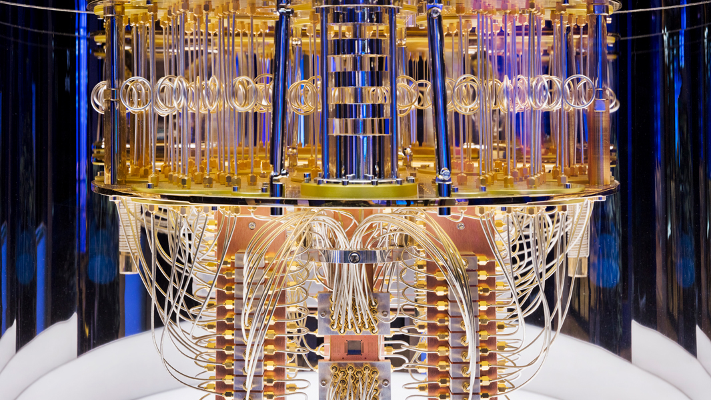

*Future*

As we move into the future, the potential applications of quantum cryptography are only just beginning to be realized. One of the most exciting prospects is the use of quantum cryptography to create a quantum internet, which would enable communication between quantum computers without any risk of interference or hacking. Additionally, quantum cryptography could be used to create secure communication networks for the Internet of Things (IoT), providing end-to-end encryption for all connected devices.

Moreover, researchers are exploring the possibilities of using quantum cryptography for secure voting systems, financial transactions, and even military applications. As the technology continues to advance, the opportunities for quantum cryptography are limitless. While there are still challenges to overcome, such as scalability and cost, the potential benefits of quantum cryptography make it an area of research that is sure to continue to grow and evolve in the years to come.



###### *Examples - Future*

Integration with classical cryptography:

In the future, quantum cryptography is likely to be integrated with classical cryptography to create hybrid systems that provide even greater levels of security.

Quantum internet:

There are plans to develop a quantum internet, which would use quantum communication to provide secure and faster communication between computers and devices. This would require the development of quantum repeaters, which are devices that can amplify and extend the range of quantum signals.

Quantum-resistant cryptography:

As mentioned earlier, quantum-resistant cryptography is an area of active research, with the goal of developing cryptographic algorithms that can withstand attacks by quantum computers.

New applications:

Quantum cryptography is likely to find new applications in areas such as secure cloud computing, secure voting systems, and secure machine-to-machine communication.

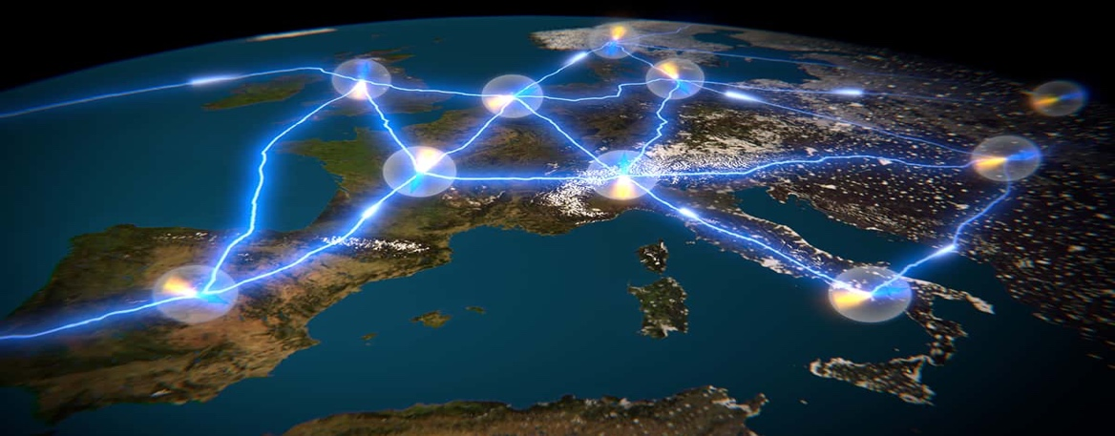

Principles of function

Uncertainty principle:

According to the uncertainty principle, it is impossible to simultaneously measure the position and momentum of a quantum particle with arbitrary precision. This means that any attempt to intercept or measure a quantum signal will disturb the state of the particle, making it impossible for an eavesdropper to obtain the same information as the intended recipient.

Superposition:

According to the principle of superposition, a quantum particle can exist in multiple states at the same time. This property is used in quantum cryptography to transmit information in the form of a qubit, which can represent both a 0 and 1 at the same time.

Entanglement:

According to the principle of entanglement, two or more particles can become correlated in such a way that their properties are intimately linked, even when separated by large distances. This property is used in quantum cryptography to distribute a secret key that is shared between the sender and receiver, which can be used to encrypt and decrypt messages.

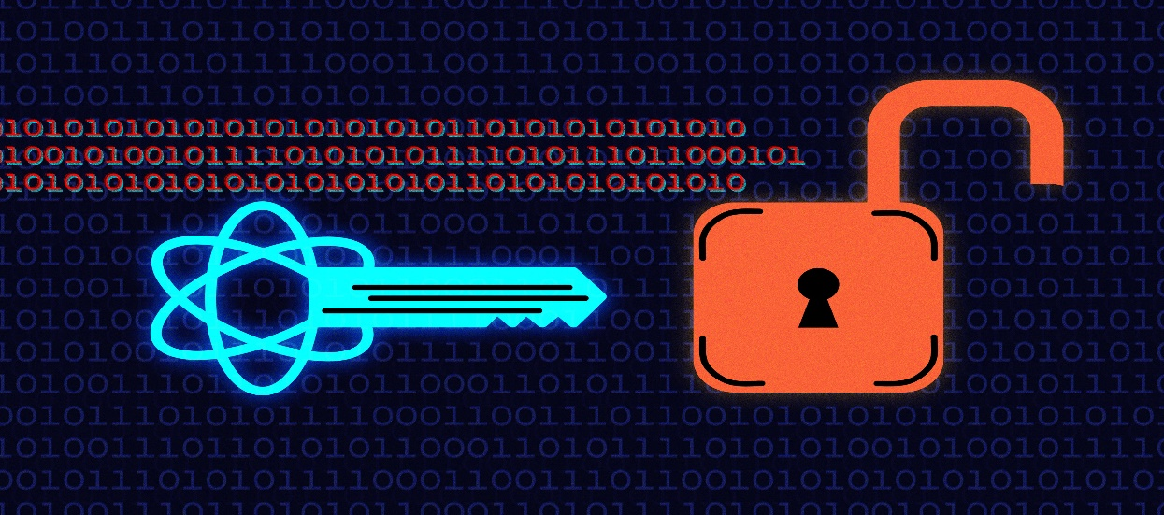

Types of implementation and deployment

Fiber-based quantum key distribution (QKD):

This is the most well-known and mature form of quantum cryptography, which uses optical fibers to transmit the qubits. Fiber-based QKD systems have been commercialized and deployed in some applications.

Free-space quantum communication:

This involves the use of lasers to transmit qubits through the atmosphere, which can be used for communication between ground-based stations or between a ground station and a satellite. Free-space quantum communication has the potential to extend the range of quantum communication beyond the limits of fiber-based systems.

Quantum random number generators:

Quantum random number generators (QRNGs) use the randomness of quantum mechanics to generate truly random numbers, which can be used for cryptographic protocols. QRNGs have been deployed in some applications, such as lottery machines and secure authentication systems.

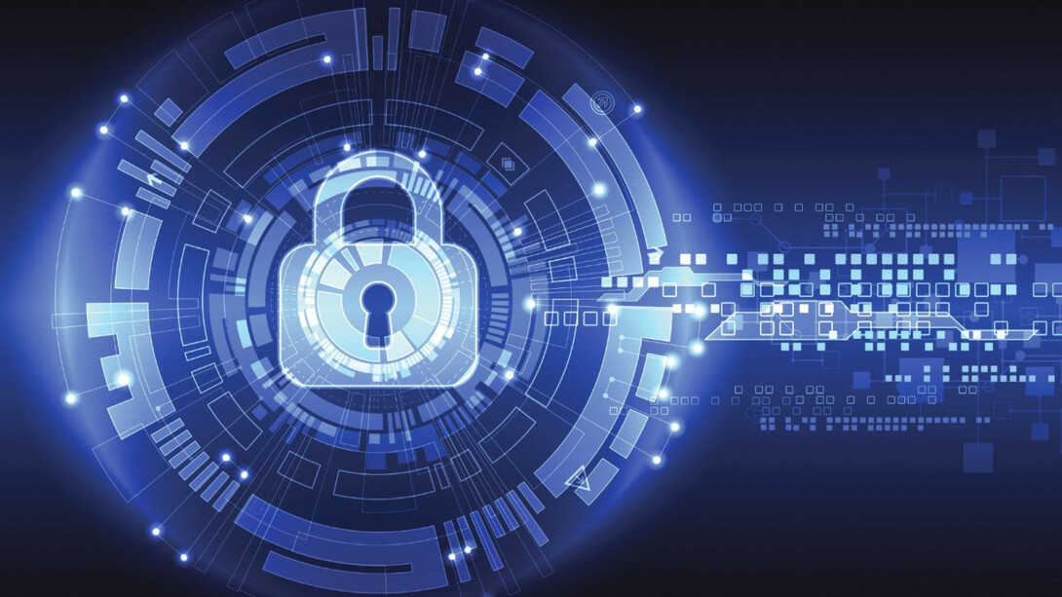

Government and military applications:

Quantum cryptography is being used in some government and military applications, such as secure communication between military units and government agencies.

Financial applications:

Quantum cryptography has potential applications in the financial sector, such as secure communication between banks and financial institutions.

Healthcare and telecommunication applications:

Quantum cryptography could also find applications in healthcare and telecommunication, where secure communication of sensitive data is critical.

Future applications:

In the future, quantum cryptography may find applications in areas such as secure cloud computing, secure voting systems, and secure machine-to-machine communication.

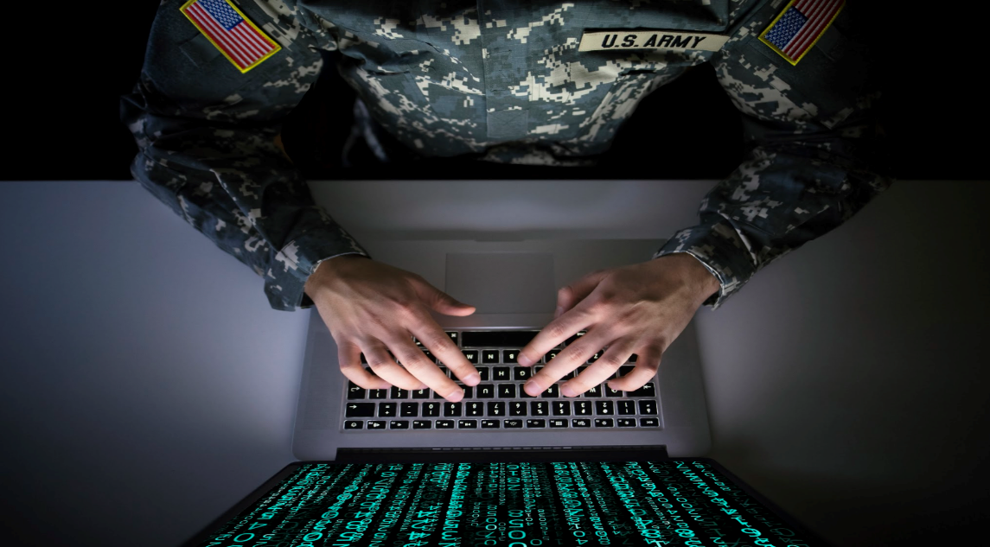

Some know real attacks in real life

* 2008 SwissQuantum network attack: In 2008, the SwissQuantum network, which was one of the first experimental quantum cryptography networks, was attacked. The attacker was able to intercept the quantum signal, and by exploiting a vulnerability in the detector system, was able to gain access to the key. The attack was detected by the system's monitoring mechanisms, and the key was regenerated before any sensitive information could be compromised.
* 2010 Vienna QKD network attack: In 2010, researchers at the Vienna University of Technology reported that they had successfully intercepted a quantum key in a quantum cryptography network. The researchers were able to exploit a weakness in the system's implementation, and by manipulating the polarization of the photons, were able to gain access to the key. The attack was a proof-of-concept demonstration rather than a real-world attack, and the researchers emphasized that the attack was only successful because of a specific vulnerability in the system they were using.
* 2017 Chinese satellite Micius QKD experiment: In 2017, researchers in China conducted a successful quantum cryptography experiment using the Micius satellite. However, they also reported that they had detected a number of attempted attacks on the system during the experiment. The attacks involved attempts to blind the satellite's detector system using laser pulses, which would have prevented the detection of any quantum
* 2019 MIT research on Trojan horse attacks: In 2019, researchers at MIT published a paper demonstrating a potential Trojan horse attack on a commercially available quantum cryptography system. The attack involved inserting a small, malicious device into the system, which could leak information about the key to an attacker. The researchers emphasized that the attack was only successful because of a specific vulnerability in the system they were using, but they also noted that such vulnerabilities are difficult to detect and could be present in other systems.

*Own opinion and possible own contribution on Present and Future of the Quantum Cryptography*

Quantum cryptography represents a groundbreaking advancement in the field of cybersecurity, offering the potential for unbreakable encryption and secure communication. In the present, we are witnessing the emergence of commercial quantum cryptography systems, with applications in government, military, and financial sectors. While the technology is still evolving, it holds great promise for revolutionizing the way we protect sensitive data.

Quantum cryptography has the potential to create a quantum internet, enabling secure and faster communication between devices and computers. This opens doors to new applications in healthcare, cloud computing, voting systems, and machine-to-machine communication, among others.

As for my own contribution to quantum cryptography, I believe that understanding and promoting awareness of this transformative technology is crucial. By educating myself and others about the principles, methods, and challenges of quantum cryptography, I can contribute to its wider adoption and appreciation. Additionally, staying updated on the latest research and advancements in the field allows me to engage in informed discussions and potentially contribute to the development of novel solutions and protocols.

*Conclusion*

In conclusion, quantum cryptography is a rapidly evolving domain that holds immense potential for the current and future landscape of cybersecurity. At present, there are already commercialized quantum cryptography systems in use, catering to sectors such as government, military, and finance. While certain challenges and limitations persist, ongoing research and development endeavors are dedicated to overcoming these hurdles.

The advent of a quantum internet has the potential to completely transform secure communication, facilitating faster and more robust connections between various devices and computers. Exciting applications in healthcare, cloud computing, voting systems, and machine-to-machine communication are on the cusp of realization, promising heightened levels of security and privacy.

To contribute effectively to the advancement of quantum cryptography, it is imperative to cultivate awareness and comprehension of its underlying principles and methodologies. Actively participating in knowledge-sharing initiatives, staying abreast of the latest research findings, and engaging with relevant communities become vital steps in this journey. Collaborative efforts with experts and researchers can pave the way for the development of novel protocols, algorithms, and countermeasures, thus fortifying the security aspects of quantum cryptography.

*References*

<https://www.forbes.com/sites/forbesbusinesscouncil/2020/07/14/the-present-and-future-of-quantum-computing-expansion/>

<https://www.researchgate.net/publication/357590106_Past_Present_and_Future_of_Quantum_Computing_A_Systematic_Study>

<https://www.mpg.de/18924407/nist-post-quantum-cryptography-standardization>

<https://kippeo.com/el-futuro-y-presente-de-la-ciberseguridad-criptografia-cuantica/>

<https://www.todolibroantiguo.es/criptografia-libros-antiguos/futuro.html>

<https://www.spiceworks.com/tech/innovation/articles/present-and-future-of-quantum-computing/>

<https://venturebeat.com/ai/quantum-computing-faces-the-ghosts-of-its-past-present-and-future/>

<https://www.hindawi.com/journals/scn/2018/8214619/?utm_source=google&utm_medium=cpc&utm_campaign=HDW_MRKT_GBL_SUB_ADWO_PAI_DYNA_JOUR_X_Partners_IET&gclid=CjwKCAjwx_eiBhBGEiwA15gLN8lQn4lC9QhVqav7l1MRaywdKZMrXJAFb0xri9P7UsCOq0DSoJBB4RoCaC8QAvD_BwE>

<https://en.wikipedia.org/wiki/Post-quantum_cryptography>

<https://www.enisa.europa.eu/news/enisa-news/post-quantum-cryptography-anticipating-threats-and-preparing-the-future>

<https://www.technologyreview.com/2019/07/12/134211/explainer-what-is-post-quantum-cryptography/>

<https://blog.cloudflare.com/experiment-with-pq/>

<https://www.cbinsights.com/research/post-quantum-cryptography/>